Little SPARK: Simple Play Adaptations to Reference for Kids

Logan Prox Talker
Description: | Image:
The Logan® ProxTalker® is an adaptable recorded speech communication device enabling independent verbal picture communication by placing any photo, symbol, or object on a sound tag card.  4 AA batteries required | 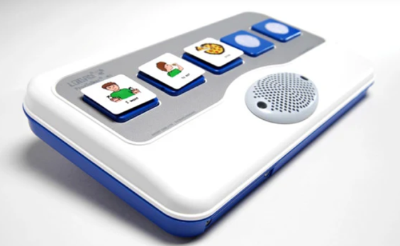

Who Might Benefit?
Those who benefit from communication supports due to challenges with verbal communication and demonstrate the fine motor skills needed to access a communication device.
Why Use?
Provides an opportunity to make choices, comment to others, and engage in simple communication exchanges with others.
Instructions for Use: | Adaptation Ideas:
Environmental Considerations  - Use in any environment and on the go, avoid using in unusually loud spaces.  Positioning & Alternate Positioning  - Use in any position or attach to any surface.  Basic Play/Use  - Place a symbol in the frame, record (if blank), and press play using the front button.  Extended Play/Use  - Use for any of the following: instruction, requests, participation, information sharing, communication, games, classroom management, or self-care skills. | Simplify It  - Introduce the levels gradually or consider using fewer cells.  - Swap the symbols for objects/photos.  Stabilize It  - Velcro to surface or place Dycem/cabinet liner underneath.  Add Sensory Cues  - Add textures to the tag.  Alternative Uses  - Directly connect to battery operated switch toys and games so that speech output can be connected to the actions of the activity.  - Share as a classroom tool to support center activities, step‑by‑step directions, build vocabulary, and model AAC use.

